Decoding Mushroom Toxicity with Logistic Regression Analysis

Submitted By:

Shams E Alam Prianka
Student ID: 2406876
Introduction

This project aims to analyze the Mushroom Dataset (UCI) using Logistic Regression with Gradient Descent. Both a custom (scratch) implementation using gradient descent and sci-kit learn Logistic Regression Model were applied. The dataset consists of 22 categorical features describing various characteristics of mushrooms and a target variable indicating whether the mushroom is non-toxic or toxic.

- Dataset Overview

- Source: UCI Machine Learning Repository
- Source link: https://archive.ics.uci.edu/dataset/73/mushroom
- Features: 22 features (e.g., cap-shape, odor, gill color)
- Instances: 8124 instances with missing values
- Target Variable: Edibility (edible vs. poisonous)
- Motivation: The dataset is well-structured, has missing values, and is ideal for binary classification.

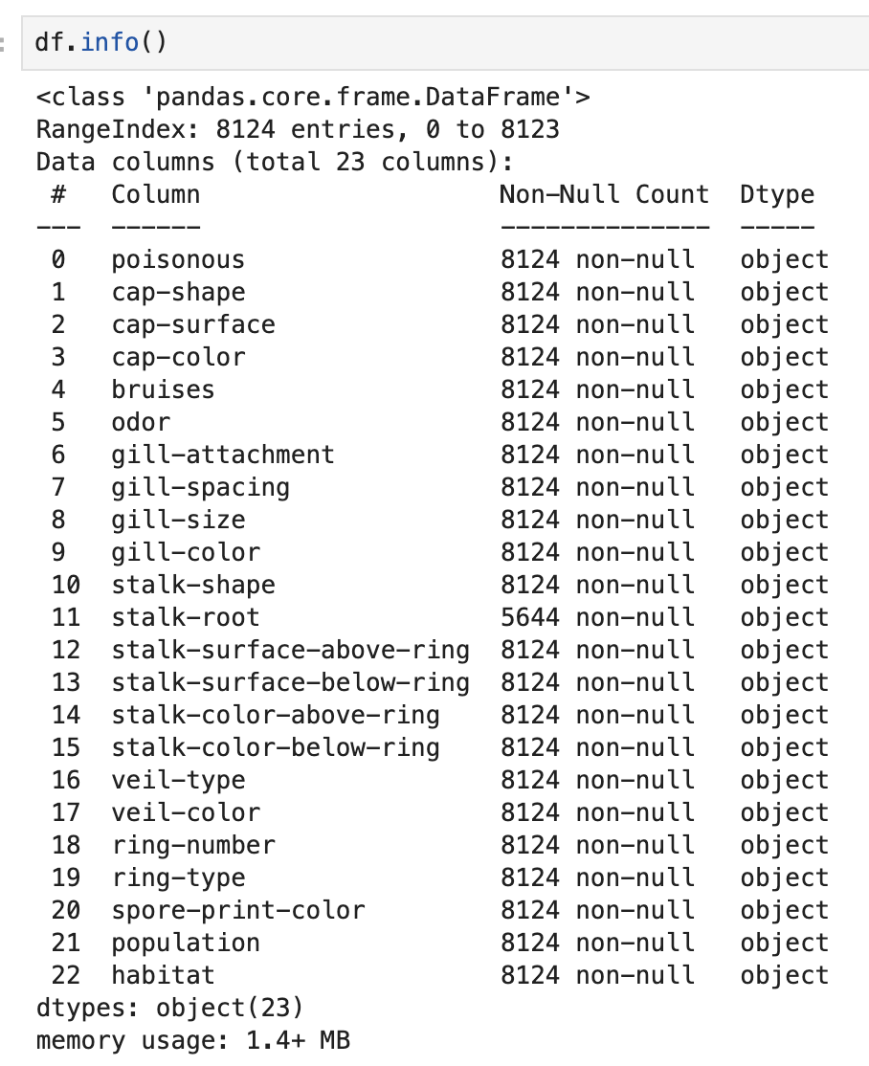

Interpretation: This justifies the need for label encoding and missing value handling. It is a clear representation that no numerical columns exist, thus one-hot encoding or label encoding is mandatory.

Convert categorical features into numerical representations:

Column | Categories | Numerical Categories
poisonous | p = poisonous  e = edible | p = 1  e = 0
cap-shape | bell=b,conical=c,convex=x,flat=f, knobbed=k,sunken=s | b = 0, c =1, f = 2, k = 3, s = 4, x = 5
cap-surface | fibrous=f,grooves=g,scaly=y,smooth=s | f = 0, g =1, s = 2, y = 3
cap-color | brown=n,buff=b,cinnamon=c,gray=g,green=r,  pink=p,purple=u,red=e,white=w,yellow=y | b = 0, c =1, e = 2, g = 3, n = 4, p = 5, r = 6, u = 7, w =8, y = 9
bruises | bruises=t,no=f | f = 0, t =1
odor | almond=a,anise=l,creosote=c,fishy=y,foul=f,  musty=m,none=n,pungent=p,spicy=s | a = 0, c =1, f = 2, I = 3, m = 4, n = 5, p = 6, s = 7, y = 8
gill-attachment | attached=a,descending=d,free=f,notched=n | a = 0, d =1, f = 2, n = 3
gill-spacing | close=c,crowded=w,distant=d | c = 0, d =1, w = 2
gill-size | broad=b,narrow=n | b = 0, n =1
gill-color | black=k,brown=n,buff=b,chocolate=h,gray=g, green=r,orange=o,pink=p,purple=u,red=e, white=w,yellow=y | b = 0, e =1, g = 2, h = 3, k = 4, n = 5, o = 6, p = 7, r = 8, u = 9, w = 10, y = 11
stalk-shape | enlarging=e,tapering=t | e = 0, t =1
stalk-root | bulbous=b,club=c,cup=u,equal=e,rhizomorphs=z,rooted=r,missing=? | b = 0, c =1, e = 2, r = 3, u = 4, ? = ?, z = 5
stalk-surface-above-ring | fibrous=f,scaly=y,silky=k,smooth=s | f = 0, k =1, s = 2, y = 3
stalk-surface-below-ring | fibrous=f,scaly=y,silky=k,smooth=s | f = 0, k =1, s = 2, y = 3
stalk-color-above-ring | brown=n,buff=b,cinnamon=c,gray=g,orange=o, pink=p,red=e,white=w,yellow=y | b = 0, c =1, e = 2, g = 3, n = 4, o = 5, p = 6, w = 7, y = 8
stalk-color-below-ring | brown=n,buff=b,cinnamon=c,gray=g,orange=o, pink=p,red=e,white=w,yellow=y | b = 0, c =1, e = 2, g = 3, n = 4, o = 5, p = 6, w = 7, y = 8
veil-type | partial=p,universal=u | p = 0, u =1
veil-color | brown=n,orange=o,white=w,yellow=y | n = 0, o =1, w = 2, y = 3
ring-number | none=n,one=o,two=t | n = 0, o =1, t = 2
ring-type | cobwebby=c,evanescent=e,flaring=f,large=l, none=n,pendant=p,sheathing=s,zone=z | c = 0, e =1, f = 2, I = 3, n = 4, p = 5, s = 6, z = 7
spore-print-color | black=k,brown=n,buff=b,chocolate=h,green=r, orange=o,purple=u,white=w,yellow=y | b = 0, h =1, k = 2, n = 3, o = 4, r = 5, u = 6, w = 7, y = 8
population | abundant=a,clustered=c,numerous=n, scattered=s,several=v,solitary=y | a = 0, c =1, n = 2, s = 3, v = 4, y = 5
habitat | grasses=g,leaves=l,meadows=m,paths=p, urban=u,waste=w,woods=d | d = 0, g =1, I = 2, m = 3, p = 4, u = 5, w = 6

- Data Preprocessing

Data cleaning: The ‘stalk-root’ column contains 2,480 missing values represented by ‘?’. To improve prediction accuracy, it's important to clean the dataset by replacing all ‘?’ entries with actual NaN values so that pandas can properly recognize them as missing. Below is a comparison of the column before and after handling the missing values.

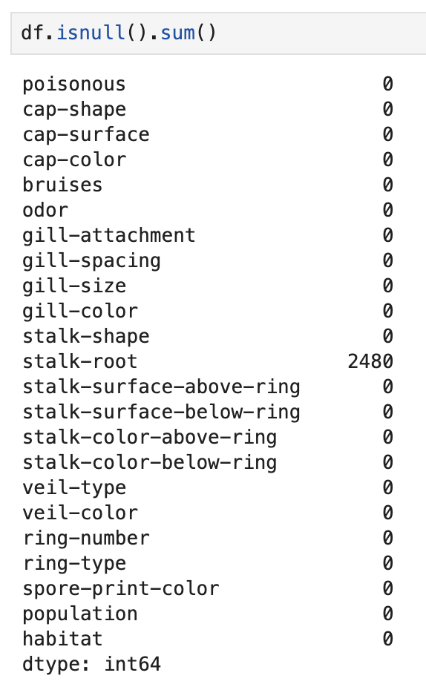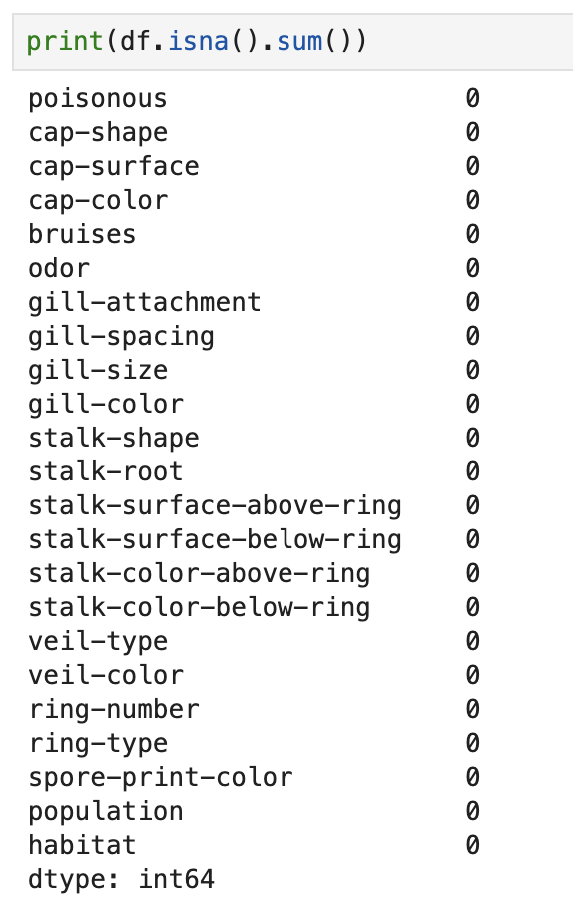

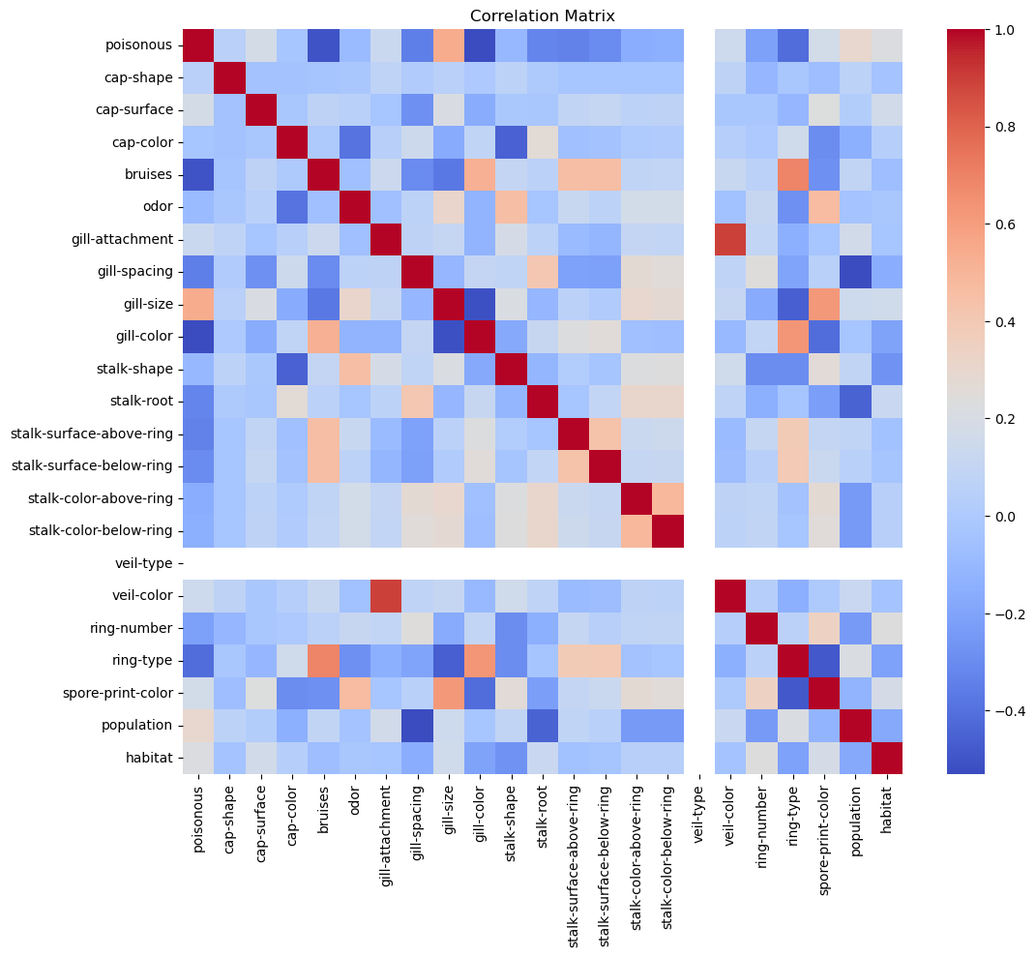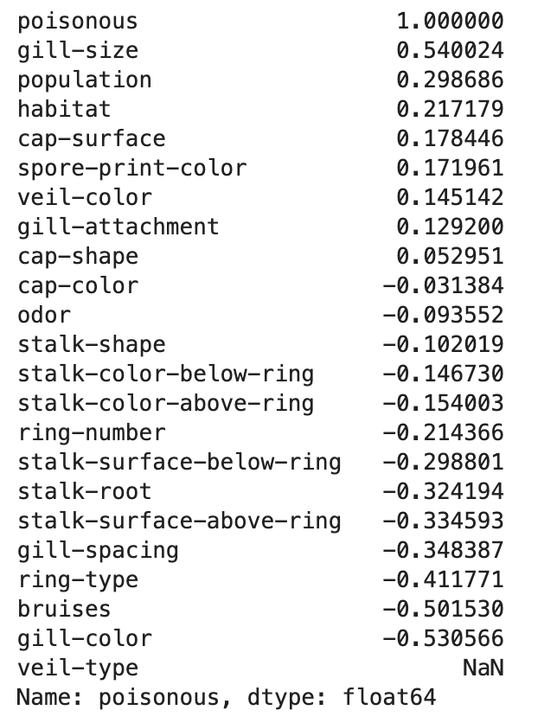

Interpretation: The correlation matrix and feature-to-target correlation table highlight the most predictive variables for identifying poisonous mushrooms. Features like gill-size, gill-color, and bruises show strong relationships with toxicity and thus are crucial in model training. While multicollinearity between features is generally low, these insights also support the interpretability of logistic regression in this binary classification problem. Finally, after examining the correlation between the feature variables, we are not planning to remove any variables moving forward.

Density plot of the features:
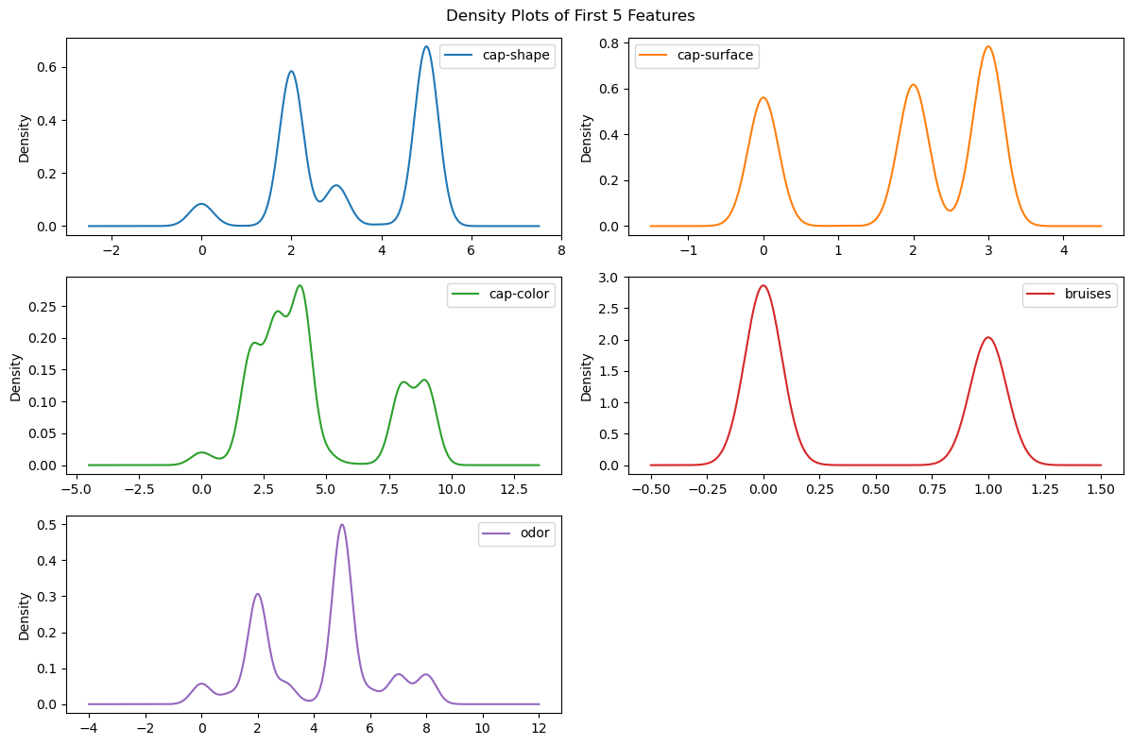

The density plots help visualize the distribution of encoded categorical variables. Features like ‘odor’ and ‘cap-color’ exhibit high variability and are likely influential in distinguishing between non-toxic and toxic mushrooms. Binary features like bruises show well-separated distributions that make them useful for classification. These plots also confirm that the label encoding process preserved meaningful distinctions in feature representation.

Boxplots:

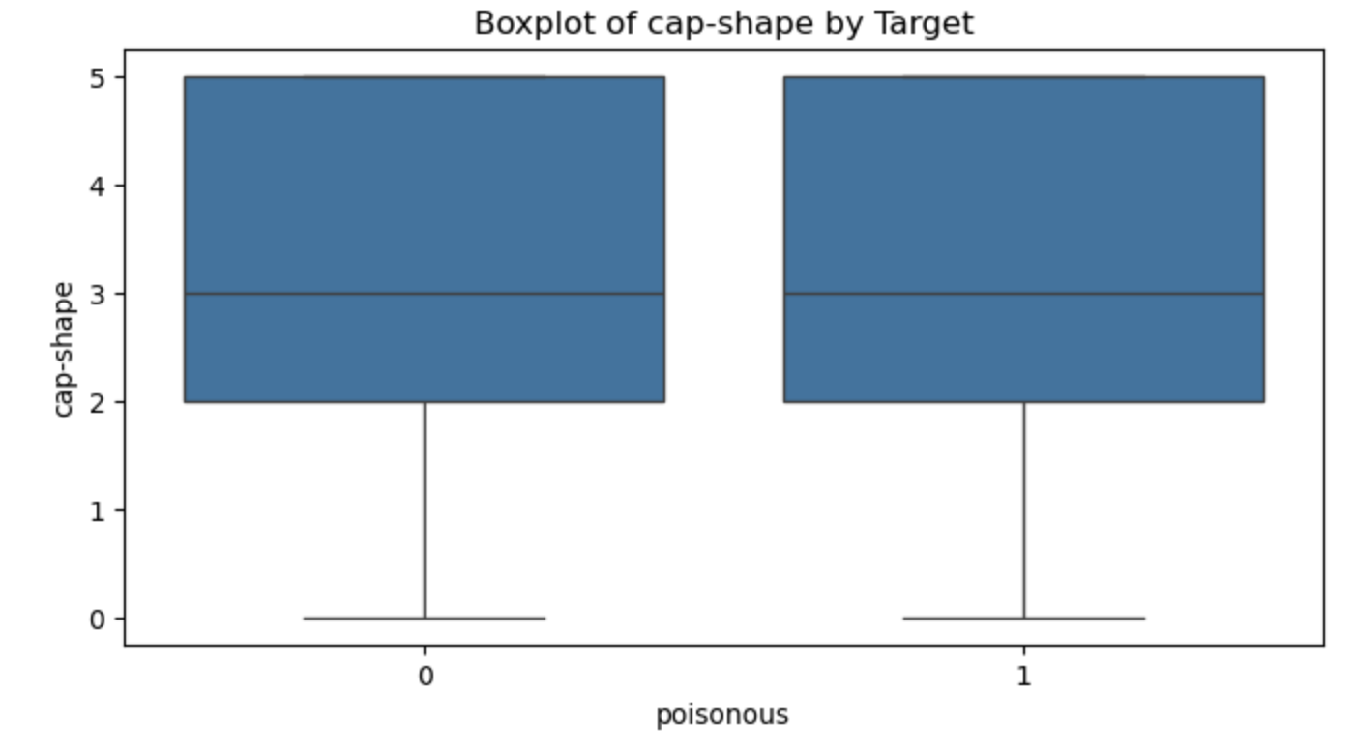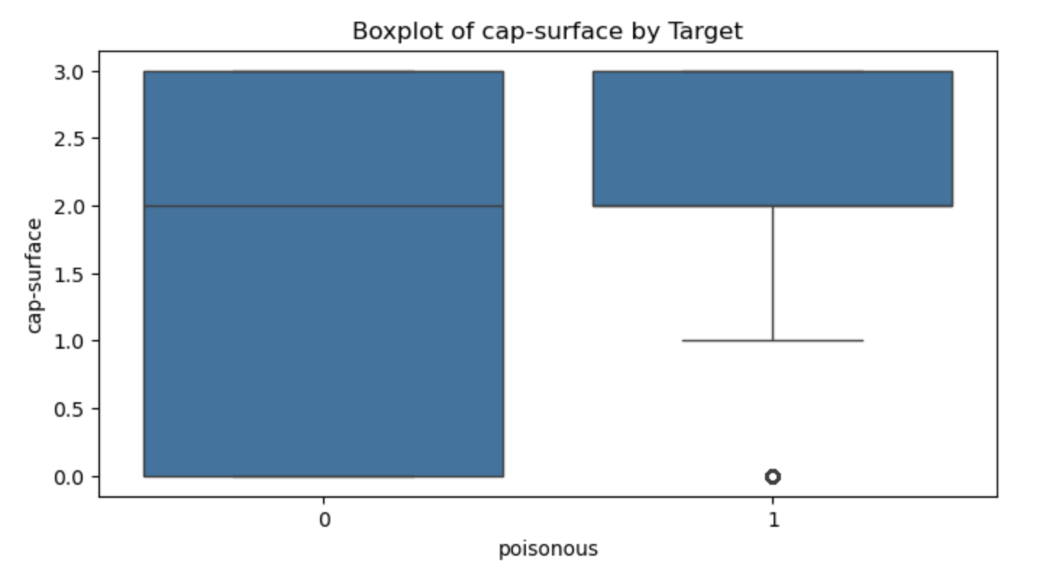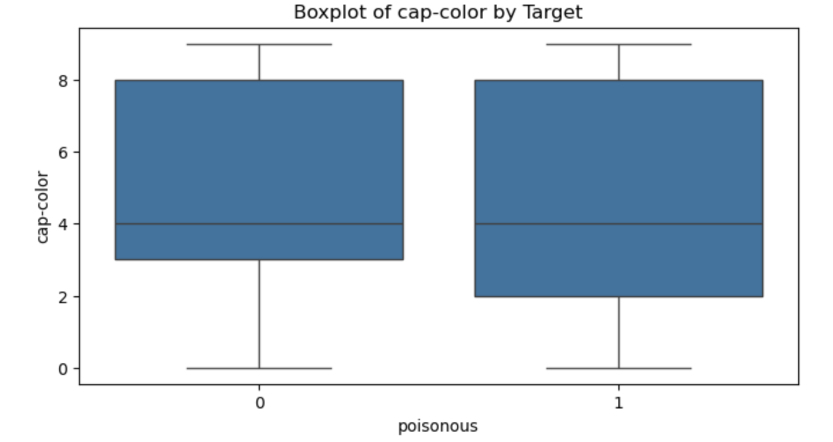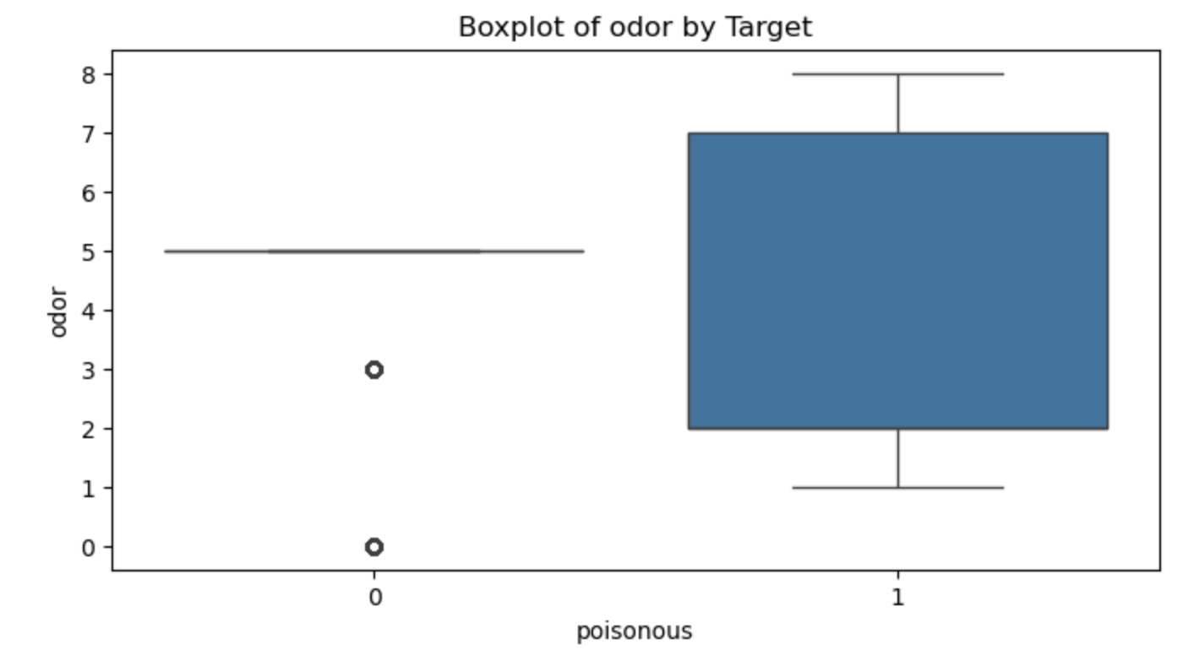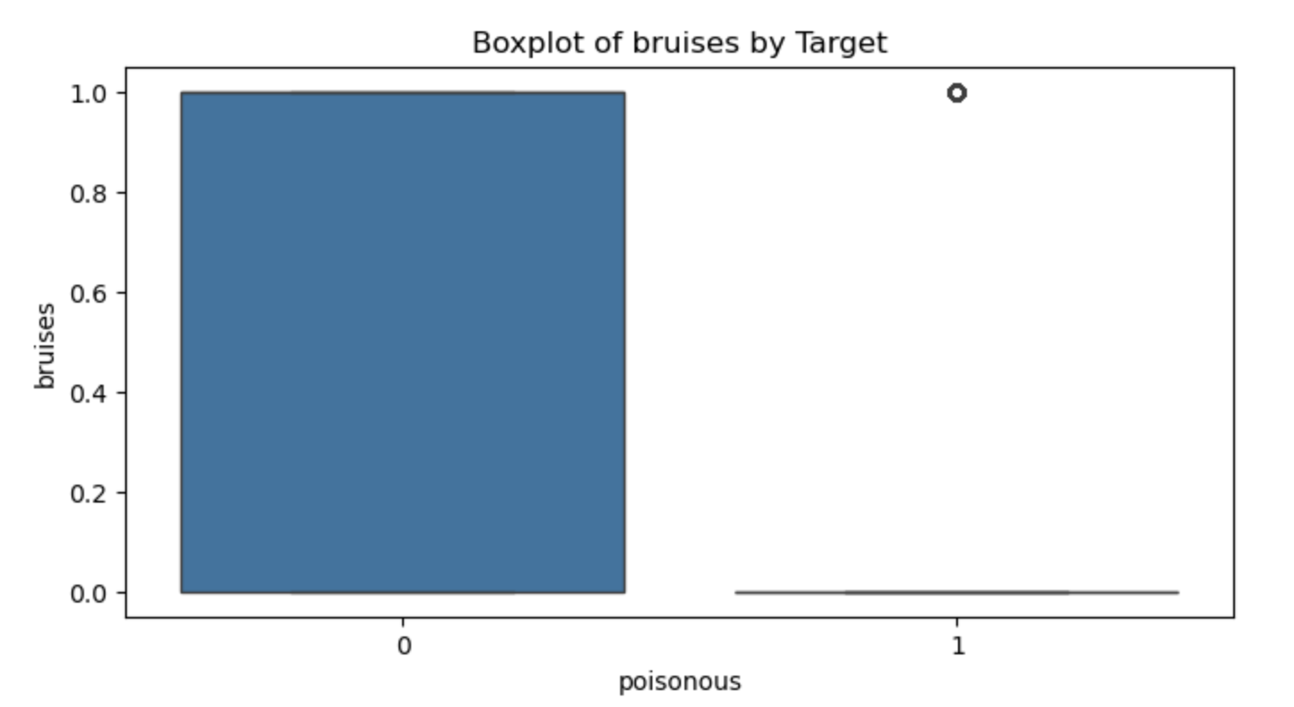

- Split dataset into training and testing sets:

The dataset was split into training and testing sets using an 80/20 split, resulting in 6,499 training samples and 1,625 testing samples. Each sample includes 22 categorical features after preprocessing. This stratified split ensures sufficient data for both model learning and validation, allowing for reliable performance evaluation on unseen examples. | 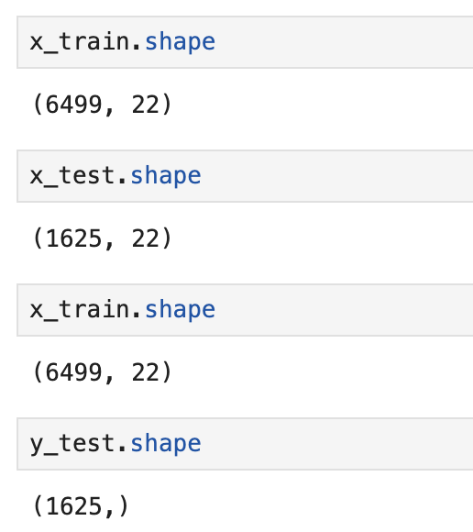

- Model Implementation:

I Implemented logistic regression from scratch using gradient descent. A learning rate sensitivity analysis shows that a higher learning rate (0.1) leads to better convergence in both accuracy and log-loss. At lower learning rates (e.g., 0.01), the model struggles to converge within the given number of iterations, resulting in lower accuracy and higher uncertainty. Thus, learning_rate = 0.1 was chosen for the final model training.

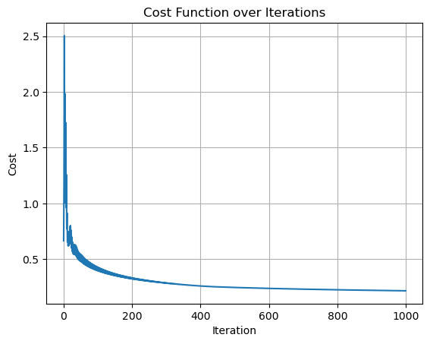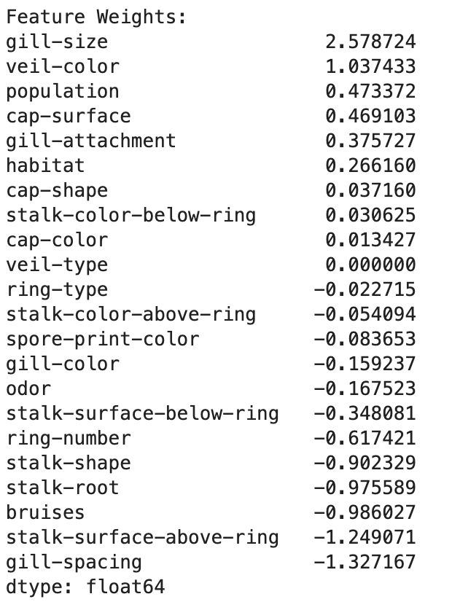

Model Configuration:

- Learning rate: 0.01
- Max Iteratiions: 1000
- Convergence Tolerance: 1e-6
- Sigmoid activation and bias term included.

Custom model summary:

Train Accuracy: 0.8817
Test Accuracy: 0.8757
Train Log Loss: 0.3278
Test Log Loss: 0.3307

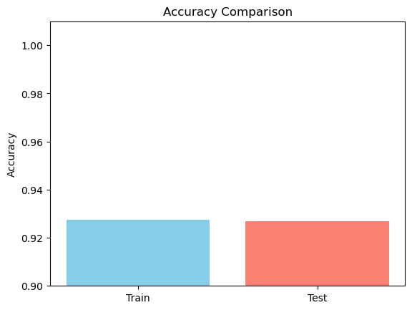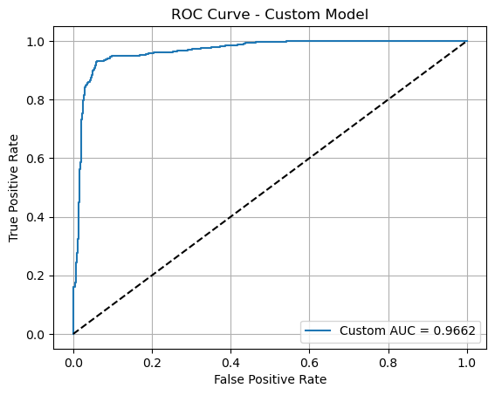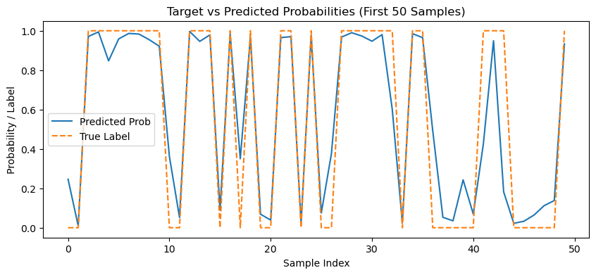

Experiment with different learning rates:

Learning rate: 0.01 | Learning rate: 0.05 | Learning rate: 0.1
Train Accuracy: 0.8817  Test Accuracy: 0.8757  Train Log Loss: 0.3278  Test Log Loss: 0.3307 | Train Accuracy: 0.9188  Test Accuracy: 0.9126  Train Log Loss: 0.2484  Test Log Loss: 0.2538 | Train Accuracy: 0.9275  Test Accuracy: 0.9268  Train Log Loss: 0.2170  Test Log Loss: 0.2259

- Chosen Final model:

- Learning rate: 0.1
- Max Iteratiions: 1000
- Convergence Tolerance: 1e-6
- Sigmoid activation and bias term included.

Custom model summary | Scikit-Learn Model Evaluation
Train Accuracy: 0.9275  Test Accuracy: 0.9268  Train Log Loss: 0.2170  Test Log Loss: 0.2259 | Train Accuracy: 0.9598  Test Accuracy: 0.9545  Train Log Loss: 0.1413  Test Log Loss: 0.1589

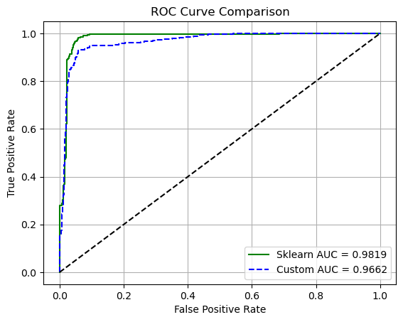
The ROC curve comparison highlights the excellent classification ability of both models. The Scikit-learn model achieved an AUC of 0.9819, while the custom implementation reached 0.9662. The curves indicate strong true positive rates and low false positive rates across various thresholds, confirming that both models are highly capable of separating edible from poisonous mushrooms. This visual metric reinforces the reliability and effectiveness of logistic regression for this binary classification task.

- Why are these results too high?

• The UCI Mushroom dataset is clean, contains only categorical variables, and has minimal noise. Many variables have clear patterns that separate edible and toxic mushrooms.
• Some odors only appear in toxic mushrooms, while others are exclusive to non-toxic ones. This allows even simple models to achieve high accuracy.
• There are no mislabeled data points or overlap between classes, making it easy for the model to learn correct associations.
• Scikit-learn’s Logistic Regression applies L2 regularization, which helps it generalize slightly better and achieve lower log loss.
• Missing values were handled, features were properly encoded, and learning rate and convergence settings were tuned. All of this improves training stability and performance.

Insights & Conclusions

The logistic regression models applied to the UCI Mushroom dataset delivered highly accurate classification results. The custom model achieved a test accuracy of 92.68% with a log loss of 0.2259, while Scikit-learn’s model performed slightly better, reaching 95.45% test accuracy and 0.1589 test log loss.

These high scores are expected given the dataset’s structure, especially the strong predictive power of features like ‘odor’ and ‘gill-size’. The learning rate experiment confirmed that 0.1 provided the best convergence, outperforming lower rates such as 0.01, which resulted in only 87.57% accuracy. Also, the outliers did not significantly affect the prediction model.

There was no indication of overfitting, as training and test metrics remained close for both models. All 22 features were retained, and proper preprocessing, including handling missing values and encoding categorical variables, contributed to reliable and interpretable outcomes.

This project validates logistic regression as a simple yet powerful approach for binary classification on clean, categorical datasets. The custom implementation closely matched the Scikit-learn model, confirming both its correctness and effectiveness.

Top of Form
Bottom of Form

